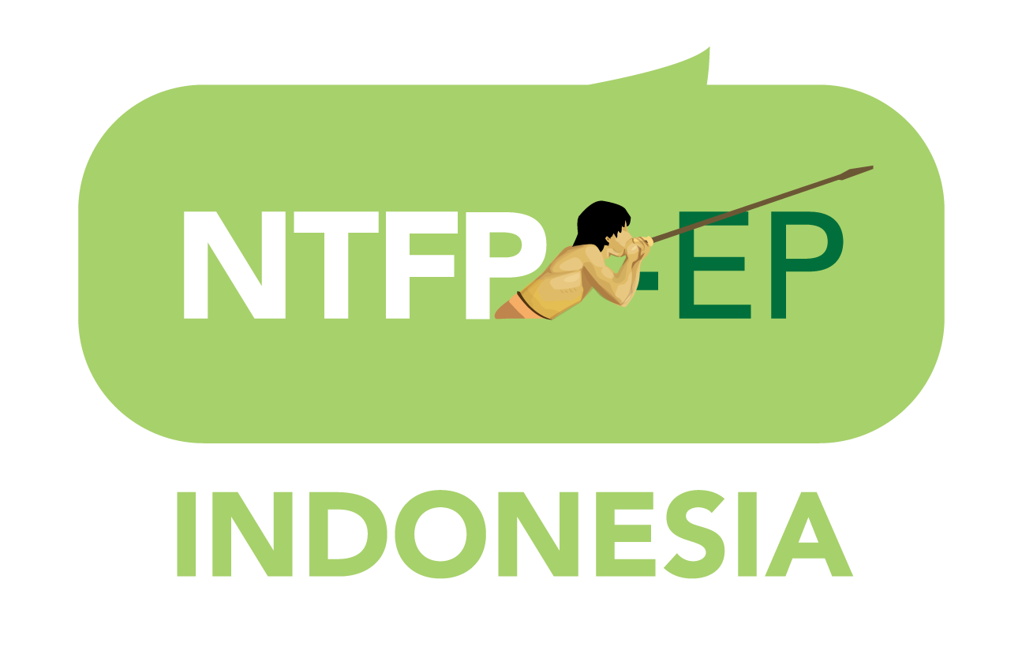

APPLICATION / PROPOSAL

I. PROJECT TITLE
- maximum of 10 words
II. NAME OF PROPONENT ORGANIZATION
III. REGION WHERE THE PROJECT WILL BE IMPLEMENTED

IV. CATEGORY
Mark the category where this proposal fits in. Note that supported grassroots initiatives should give particular attention to the protection of environmental defenders (see part A of the guidelines) through:

1). Capacity building trainings for the target communities in the SP-landscapes;
2) Legal Assistance;
3) Emergency funds. For the relocation of a threatened environmental defender to a safe place and if needed emergency relief for his/her family members. (see part B of the guidelines)

III. CONTACT INFORMATION
- Contact person

- Address (address, email and contact numbers)

- Bank Details: (should be a group/organizational account; not a personal account)
Name/s of group/organizational account -
Account number -
Bank name-
Bank address -
SWIFT CODE/IBAN –

IV. AMOUNT REQUESTED
- Please indicate total budget in Rupiah
- Budget breakdown should be in separate Budget Proposal format
- If budget breakdown is in local currency, please indicate exchange rate used to convert to Euros

V. TIME FRAME
- Please indicate number of months project will be implemented

VI. DESCRIPTION OF THE SITUATION AND RATIONALE FOR THE PROJECT
- For your guidance, carefully refer to the SRJS OF guideline for the SRJS aim and the thematic coverage and priorities of the OF.
- Please provide a map, either a hand sketch or illustration, where project is to be implemented.
- Briefly describe the biodiversity situation – flora and fauna – and general poverty situation of the project area and relate how they can benefit from your project.
- Please provide a brief profile on the project beneficiaries ensuring gender disaggregation of data and indicating number of households that will be directly involved and, if possible, identifying number of female-headed households.

VII. GENERAL OBJECTIVE OF THE PROJECT
VIII. RESULTS TO BE ACHIEVED BY THE PROJECT
- At the end of the project, we want to see this improved (result)

- At the end of the project, we want to see these following signs (indicators) to tell that we have become successful in achieving our result (quantitative and/or qualitative)

IX. DESCRIPTION OF ACTIVITIES
X. COLLABORATING PARTNERS
- Short description of partners to be involved in the activity and their level of involvement
XI. DESCRIPTION OF THE ORGANIZATION
- Short description of the community based organization (mission, vision, objectives)

- Number of staff and volunteers

- Main activities / projects implemented prior to the proposed initiative

- Other sources of funding

XII. OTHER DONORS APPROACHED FOR THIS INITIATIVE ( if applicable)
XIII. BUDGET (see separate Budget Detail sheet in MS Excel format)

